BUILD AN EVENT MANAGEMENT USING SALESFORCE

1. INTRODUCTION

1.1 Overview

Our company is hiring for an event manager. We appreciate you taking the time to review the list of qualification and to apply for the position. If you don’t fill all of the qualification, you may still be considered depending on your level of experience.

1.2 Purpose

* Stakeholder meetings to plan scope of events, establish

and monitor budgets, or review procedures.

* Maintains records related to venues and vendors.
* Ensures the details of the services provided are carried out smoothly.
* Examines the total plans for the event to determine what is needed.
* Supports the event manager responsible for the various “Big 5” events. (New Students Orientation, Reunion home coming, Parents Weekend, admit Weekend, and commencement)
* Maintains relationship with internal and external partners.
* Research and provide recommendations for potential event location, and evaluate alternatives.
* Liaison to Student groups and the student activities and leadership advising on event orders, venues and other LBRE services or resources.

2. Problem Definition & Design Thinking

2.1 Empathy Map

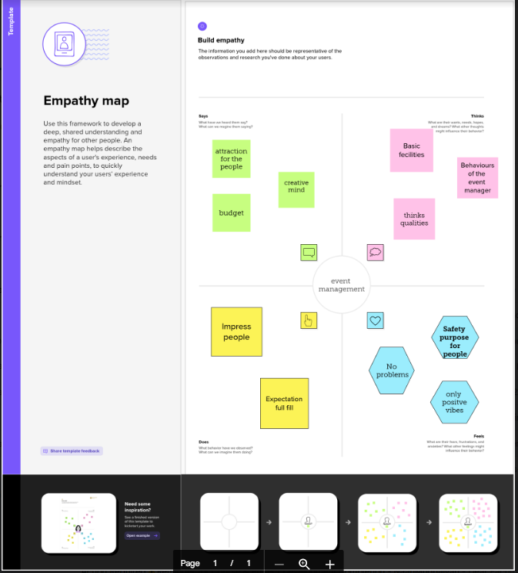

2.2 Ideation & Brainstorming Map

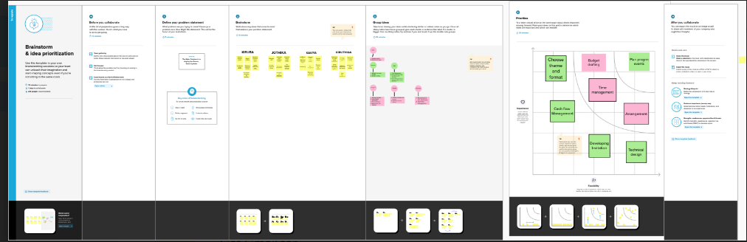

3. Result

3.1 Data model

|  |  |
| --- | --- |
| Object  Name | Fields in the object |
| Events | |  |  | | --- | --- | | Field Label | Data Type | | Events | Text | |
| Attendees | |  |  | | --- | --- | | Field Label | Data Type | | Id | Auto Number | | Phone | Phone | |

|  |  |  |  |  |  |
| --- | --- | --- | --- | --- | --- |
| Speakers | |  |  | | --- | --- | | Field label | Data Type | | Bio | Text Area | |
| Vendors | |  |  | | --- | --- | | Field Label | Data Type | | e-mail | Email | |

3.2 Activity & Screenshot

Milestone – 5

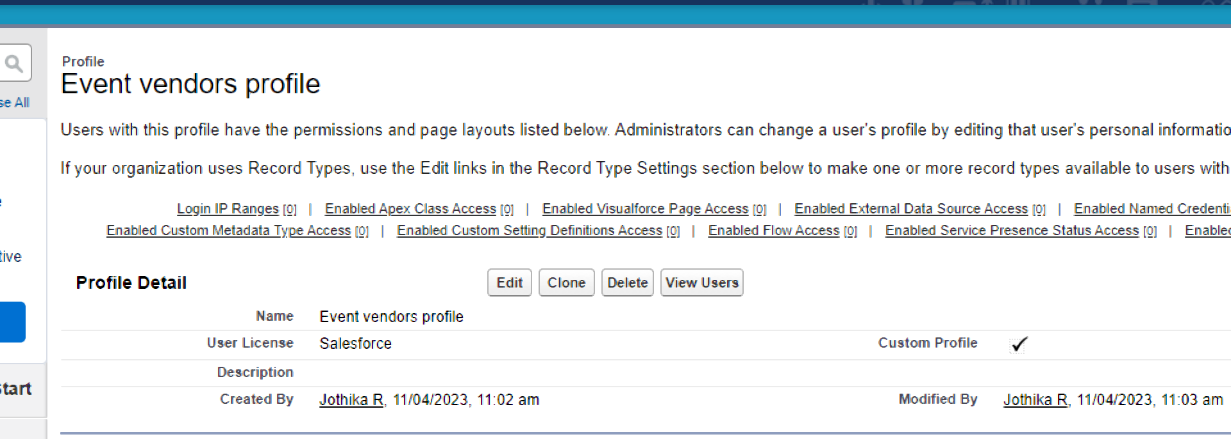

Milestone – 6

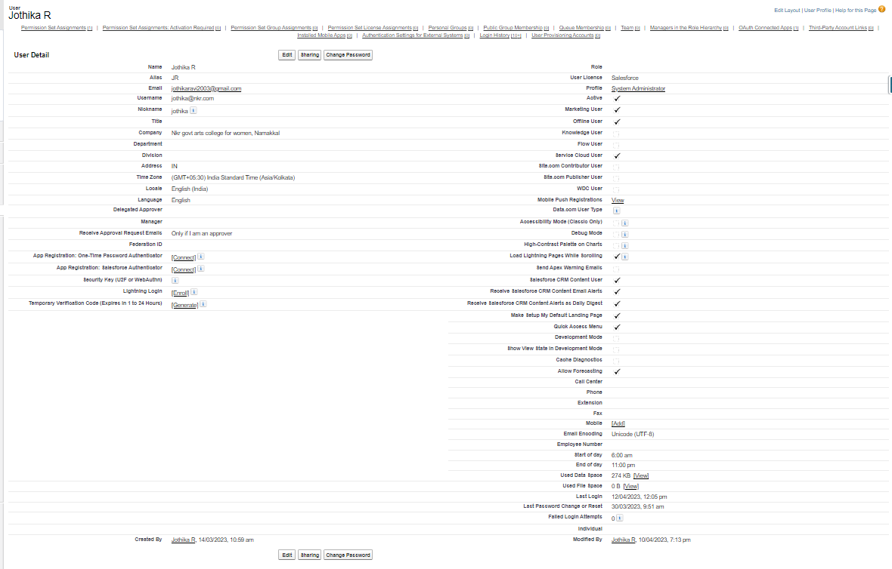

Milestone – 7

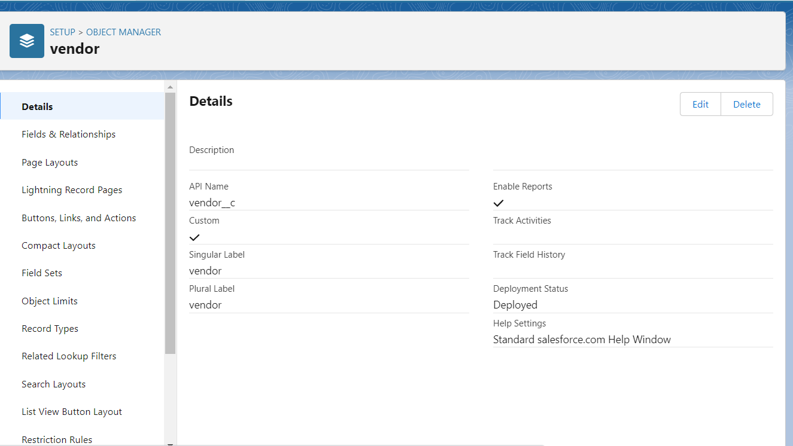

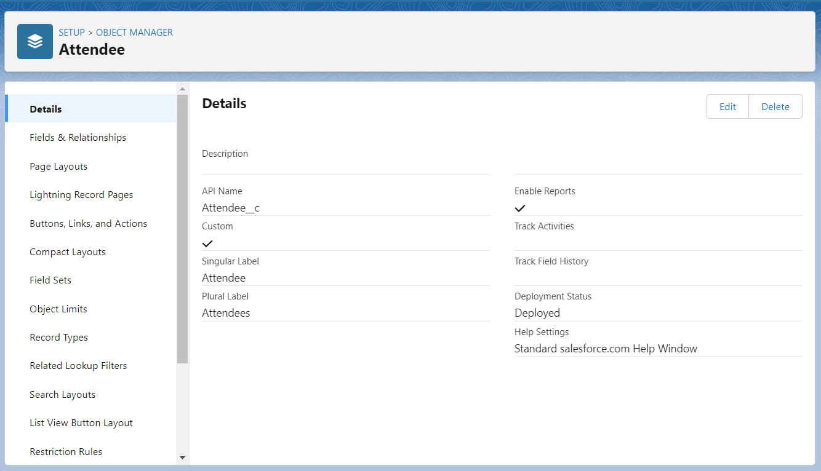

4. Trailhead Profile Public URL

Team Lead : <https://trailblazer.me/id/kkumar2063>

Team Member 1 : <https://trailblazer.me/id/jothr3>

Team Member 2 : <https://trailblazer.me/id/kavis103>

Team Member 3 : <https://trailplazer.me/id/kirur5>

5. Advantages & Disadvantages

Advantages

* Planning reduces uncertainty.
* Planning is focused on objectives.
* Planning encourages creativity.
* Planning anticipates problems and cope with change.

Disadvantages

* Planning is time-consuming process.
* Planning could lead to lack of reliable data.
* Planning could be costly process.
* Planning leads to rigidity.
* Planning is resistance to change.

6. Applications

* Reduce Administration workload.
* Maximize flexibility.
* Save time planning events.
* Prevent missed communication.

7. Conclusion

* Event Management is a glamorous and exciting profession which demands a lot of hard work and dynamism. As the name suggests, it means conceptualizing, planning, organizing and finally executing an event.
* The events could be of any type-musical source, concert, exhibition, product launching etc.

8. Future Scope

Event Management as a career is a multifaceted activity. It involves management, creation and development of events such as corporate conferences, wedding, festivities, formal parties, etc.,